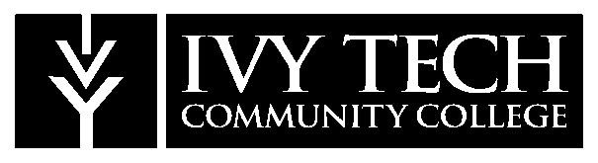 NEWS RELEASE

FOR IMMEDIATE RELEASE – Friday, September 27, 2019

For further information, contact:
Kelsey Batten
(317) 917-5732
kbatten1@ivytech.edu

Ivy Tech Foundation honors Benefactors of the Year

INDIANAPOLIS, Ind. – The Ivy Tech Foundation recently recognized 15 winners at the ninth annual Benefactor Awards Dinner, held on September 26 at the French Lick Hotel.

During this event, the Foundation honors individuals, corporations and foundations from Indiana who have considerably impacted Ivy Tech communities and students. The award celebrates the gifts and volunteer service that has been contributed to the College.

“With our deepest appreciation, we celebrate each of our Benefactors for their passion, unconditional commitment and enduring dedication to the success of our students,” said John M. Murphy, President of Ivy Tech Foundation. “Our Benefactors are incredibly generous community leaders who are creating future opportunities for our friends, families and neighbors and we are extremely grateful.”

The following benefactors received an award for 2019:

- Anderson: Jim Ault
- Bloomington: Kathy and Randy Vernon
- Columbus: National Center for Complex Operations
- Evansville: Nelda and Thomas Hickey
- Fort Wayne: Brooks Construction Company, Inc.
- Indianapolis: Susannah Dillon
- Kokomo: Kokomo Grain Co.
- Lake County, Valparaiso, Michigan City: Duneland Health Council
- Lawrenceburg: City of Lawrenceburg
- Marion: Dr. Harry D. Brickley
- Muncie: George and Frances Ball Foundation
- Lafayette: Jim Shook
- Richmond: First Bank Richmond
- Sellersburg: Leo Braddock
- Terre Haute: Lori and Steve Danielson

For more information, photos and biographies for each recipient, visit ivytech.edu/benefactors.

About Ivy Tech Community College

Ivy Tech Community College serves communities across Indiana, providing world-class education and driving economic transformation. It is the state’s largest public postsecondary institution and the nation’s largest singly accredited statewide community college system. It serves as the state’s engine of workforce development, offering high-value degree programs and training that are aligned with the needs of its communities, along with courses and programs that transfer to other colleges and universities in Indiana. It is accredited by the Higher Learning Commission and a member of the North Central Association.
# # #

